**Blackjack**

blackjack is the American variant of a globally popular banking known as twenty one. It is a comparing card game between one or more players and a dealer, where each player in turn competes against the dealer. (Baldwin, 1956). At a casino blackjack table, the dealer faces five to seven playing positions from behind a semicircular table. Black jack can be played with one to eight 52 decks of cards and you can choose as to weather to use aces as eleven or one. Tens and face cards serves as ten points , the aim is to reach 21 points for one to win . the value of a hand is the sum of the values of the individual cards, except that 21 cards value is the highest , consisting of ace or any other 10 points . (Winzard, 2010).When the dealer’s up card is a good one ,7 and above ,or an ace , the player should not stop drawing until a total of 17 is reached , else the player should not stop drawing until he gets a total of 12 or higher . Normally when playing , the player and the dealer must place a bet and each time one wins , they have to collect their money from the one that has lost . there is a possibility for one to have an insurance side.

The variation to this game is that it will constantly use ace as one , not eleven and this game will instead of having a choice to play with n number of decks , it will only play with one deck of cards and there will be no betting’s & only the player and the dealer can play here ( no physical human can play , only the computer and a human).

the aim is to make it this game less complex and more friendly , for the possibility that anyone can play ,but the design table will not be the usual , as the graphic user interface will be more attractive but also less complex for understandability ,some features will be removed , that exist in the standard blackjack.

This project aims to implement a card game in java with the following milestones : the first is to code the face values using a switch method that will later convert the values into a string of characters and the enumerator to hold the suits .only 2 player can play this game ,which is the computer and the human and the program will keep track of the states. Different colors in the gui will be used ,that are different from the standard blackjack , for examples Hit stay buttons will be purple , just to increase attractiveness and to make the player feel royal . Finally this project will be submitted on GitHub in a form of a code for assessment and the project document ,which will include the revision and extension of this proposal with screenshots that explains the game

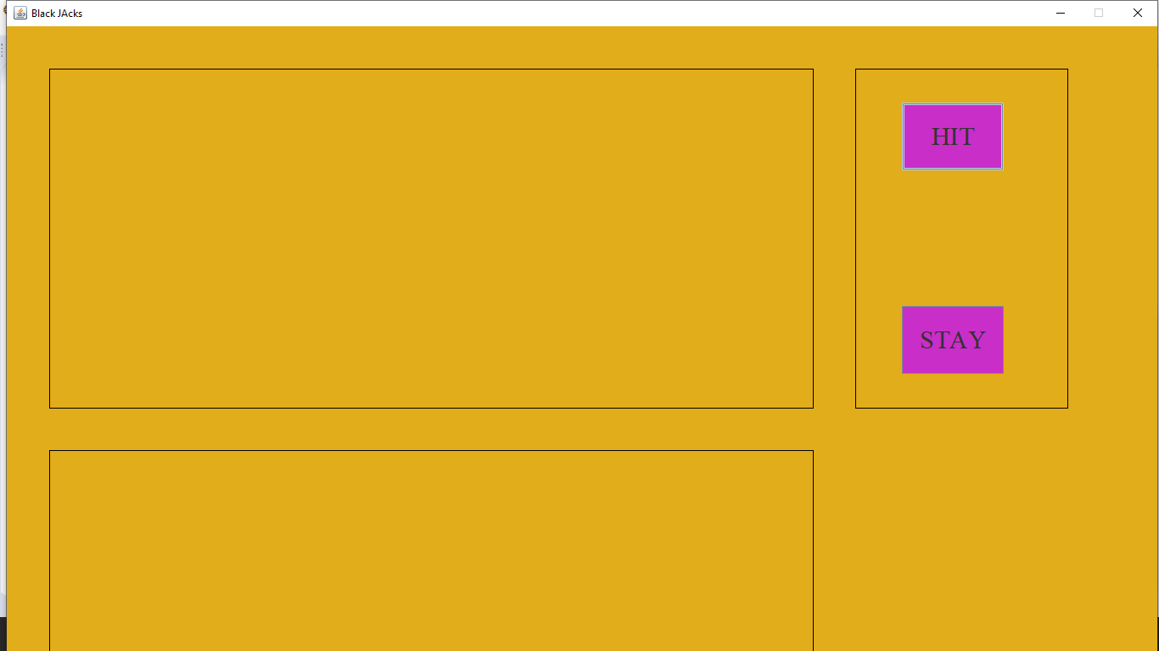

When the player hoovers the mouse over the button , it will respond by blue lining around the button , if the player clicks the Hit button , cards will be shuffled and displayed ,in this case to the console ,as cards are not added to the graphic user interface.

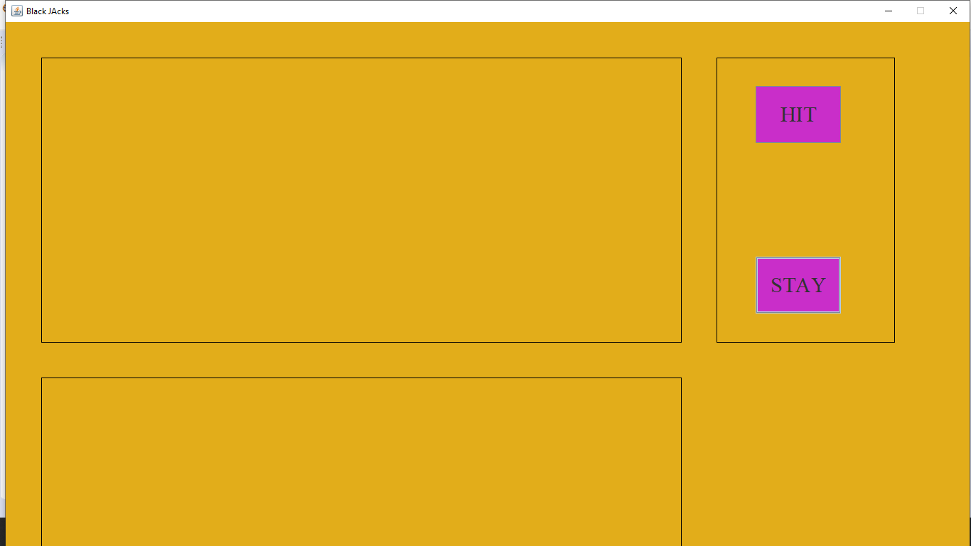

Similarly when the player hoovers the mouse over the stay button , the blue linings will appear ,but the stay button can only be useful after the cards have been shuffled , and displayed .

# References

Baldwin, R. (1956). The optimum stratergy in blackjack. *Beat the dealer*, 3-43.

Winzard, E. (2010, 03 08). *Winzard Stratergy*. Retrieved from winzardfodds.com: https://wizardofodds.com/games/blackjack/basics/